**********************************************************************
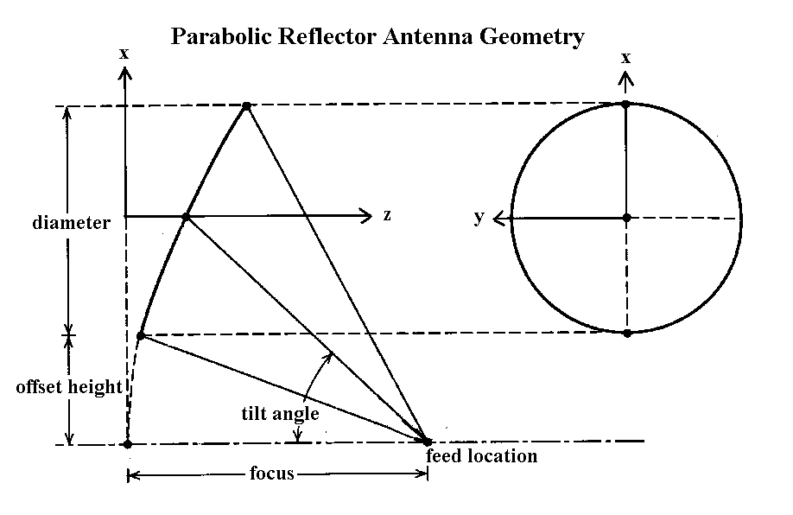
%*******************************************************************
% Reflector
%*******************************************************************
% The MATLAB program computes the radiation of a parabolic reflector.
% It can be used to investigate the:
% 1. Directivity
% 2. Sidelobe level
% 3. Polarization
% 4. Near-to-far zone fields
% *******************************************************************
% The program is based on the formulation and associated Fortran Computer Program
% of the following article:
%
% B. Houshmand, B. Fu, and Y. Rahmat-Samii, “Reflector Antenna Analysis Software”
% Chapter 11, CAEME, Center of Excellence for Multimedia Education,
% Software Book, Vol. II, Editor by M. F. Iskander, CAEME Center,
% Electrical Engineering Dept., University of Utah, Salt Lake City, UT.
%
% The reader is encouraged to read the above article for technical details.
%
%*********************************************************************
% Typical Input Data Values
% ....................................................................................................................................
% Frequency (GHz) 3
% ....................................................................................................................................
% Reflector Information:
% ....................................................................................................................................
% Focus (meters) 6
% Diameter (meters) 6
% Offset height (meters) 0
% .....................................................................................................................................
% Feed Information:
% ......................................................................................................................................
% Feed location of x axis (meters) 0
% Feed location of y axis (meters) 0
% Feed location of z axis (meters) 6
% Feed tilt angle (degrees) 0
% Number of integration points per wavelength (typically 4) 4
% q parameter for feed pattern [f(θ )=cos^{q}(θ )] 2
% ........................................................................................................................................
% Observation Information
% .....................................................................
% Radial distance to observation point (typically 1,000 m) 1000
% Minimum theta angle (degrees) 0
% Maximum theta angle (degrees) 30
% Phi angle (degrees) 0
% Number of observation angles 31
% [typically =theta(max)-theta(min)+1 for one-degree increments]
% .........................................................................................................................................
% Polarization Information
% .........................................................................................................................................
% Example: Circular polarization
% X POL 1
% Y POL 1
% Phase difference PSI between X POL and Y POL (degrees) 90
% ........................................................................................................................................
% ********************************************************************

